Lab: Install Hadoop 1.3 using Ambari

|  |  |
| --- | --- |
| **Objective:** | To install a Hadoop cluster using Ambari UI. |
| **Successful Outcome:** | You can see the various HDP 2.0 services running from within the Ambari UI. |
| **Before You Begin:** | Log into the sandbox. |

1. Install **ambari-server**
   1. From the command line of sandbox, enter the following command:

# yum -y install ambari-server

1. Copy JDK-7.x into Ambari setup folder.
   1. Ambari downloads JDK 7 during the setup process. We can avoid downloading by copying it manually into Ambari setup folder, execute the following script:

# /root/scripts/copy_jdk.sh

1. Setup ambari-server
   1. The Ambari Server manages the install process. Run the Ambari Server setup using the following command:

# ambari-server setup -s

**NOTE**: The -s option runs the setup in silent mode, meaning all default values are accepted at any prompts.

* 1. Now start the Ambari Server:

# ambari-server start

1. Login to Ambari
   1. Start Firefox browser in the VM (4th icon from top):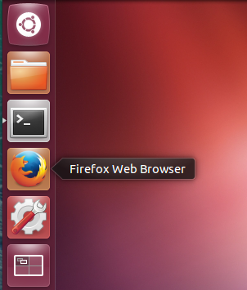
   2. Navigate to following URL:

**http://sandbox:8080**

* 1. Log in to the Ambari server using the default credentials admin/admin:

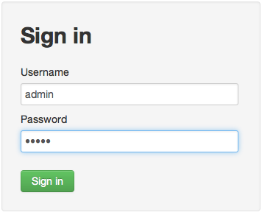

1. Run the Install Wizard
   1. At the Welcome page, enter the name “**horton**” for your cluster and click the Next button.

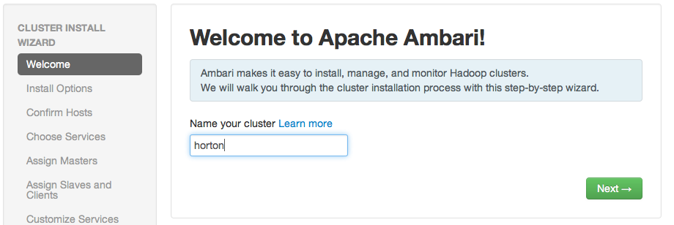

* 1. Select the service stack HDP2.1:

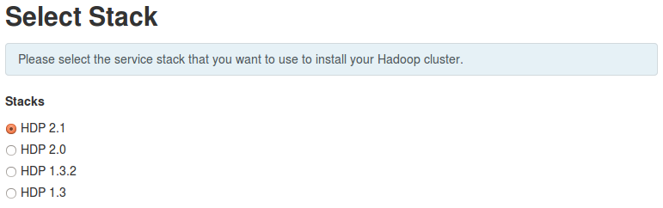

1. Under “Advanced Repository Options”, uncheck “Red Hat 5” & “SLES 11” and update URL for “Red Hat 6” as mentioned below http://sandbox/hdp/HDP-2.1.2.0

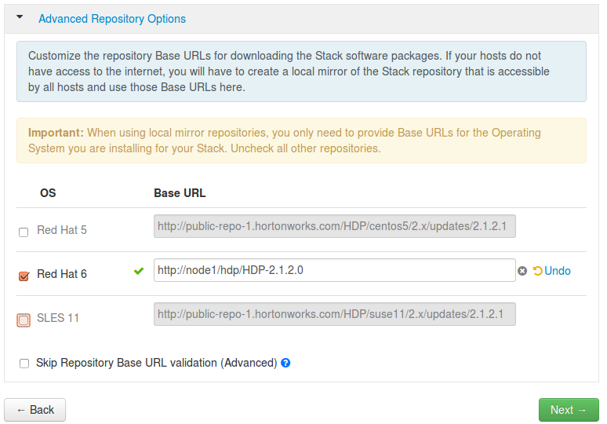

* 1. Click “Next” button

1. Enter the Host and SSH Key Details
   1. Enter sandbox, node2 and node3 in the list of Target Hosts. (Do not enter node4; you will add that node to the cluster in a later lab.)

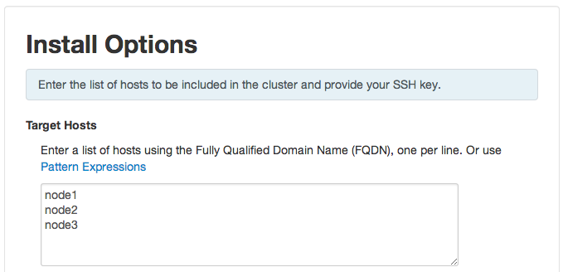

* 1. In the Host Registration Information section, click the Choose File button, then browse to and select the training-keypair.pem file (it must be pre-selected, if not you can find it on “Desktop”) :

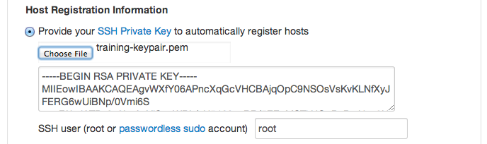

* 1. Click the Register and Confirm button. Click OK if you are warned about not using fully qualified domain names.

1. Confirm Hosts
   1. Wait for some initial verification to occur on your cluster. Once the process is done, click the Next button to proceed:

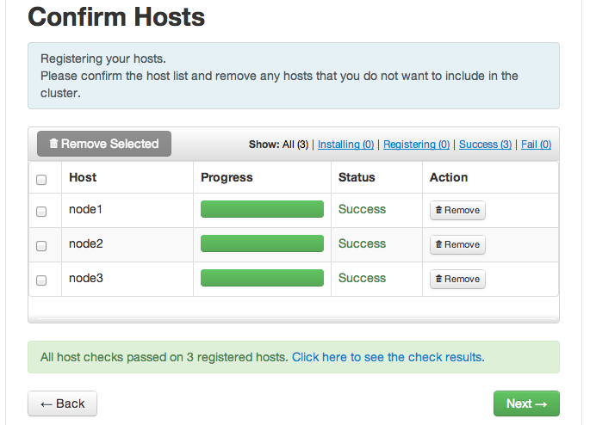

1. Choose the Services to Install
   1. Hortonworks Data Platform is made up of a number of components. You are going to install following services on your cluster initially (Uncheck HBase, Falcon & Storm, we will install them later):

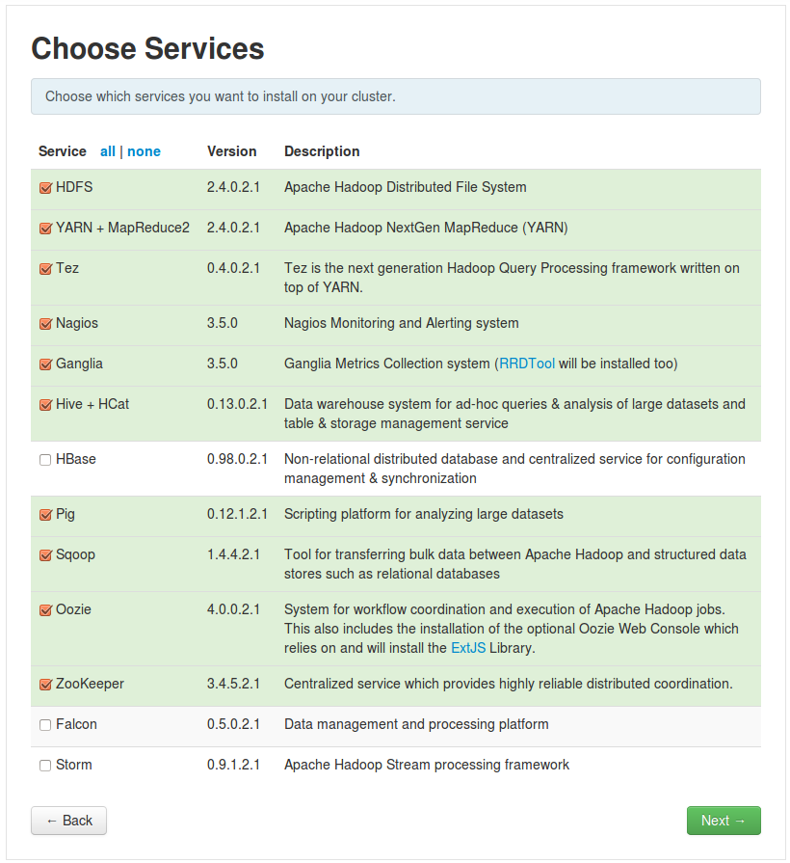

* 1. , Click the **Next** button:

1. Assign Master Nodes
   1. The Ambari wizard attempts to assign the various master services on appropriate hosts in your cluster. **Carefully choose the following assignments of the master services.**

**CAUTION**: Make sure to choose the right node for each master service as specified below. Once the installation starts, you cannot change the selection!

|  |  |
| --- | --- |
| **NameNode:** | sandbox |
| **SNameNode:** | node2 |
| **History Server:** | node2 |
| **App Timeline Server** | node2 |
| **ResourceManager:** | node2 |
| **Nagios Server:** | node3 |
| **Ganglia Server:** | node3 |
| **HiveServer2:** | node2 |
| **Oozie Server:** | node2 |
| **ZooKeeper:** | sandbox |
| **ZooKeeper:** | node2 |
| **ZooKeeper:** | node3 |

* 1. Verify your assignments match the following:

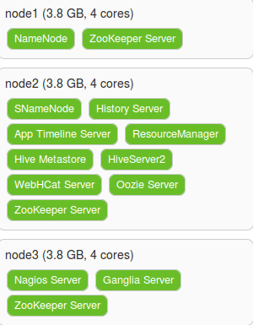

* 1. Click the Next button to continue.

1. Assign Slaves and Clients
   1. Assign **all** slave and client components to allnodes in the list:

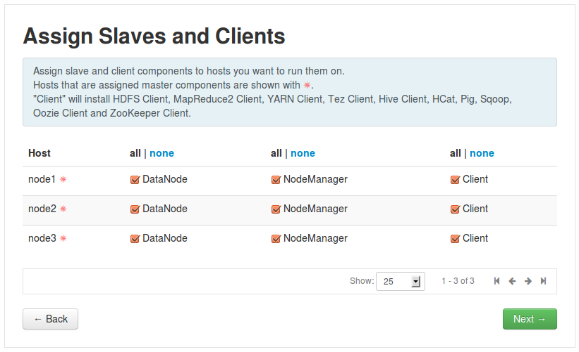

* 1. Click the Next button to continue.

1. Customize Services
   1. Notice three services require additional configuration: Hive, Oozie and Nagios. Click on the Hive tab, then enter hive for the Database Password:

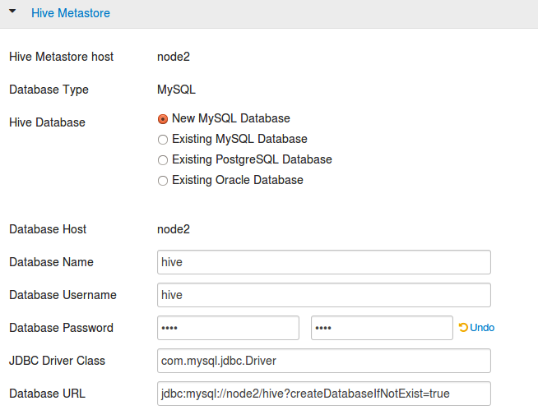

* 1. Click on the Oozie tab and enter oozie for its Database Password:

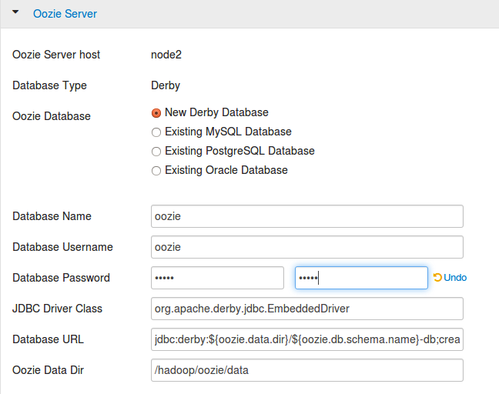

* 1. Click on the Nagios tab. Enter admin for the Nagios Admin password, and enter your email address in the Hadoop Admin email field:

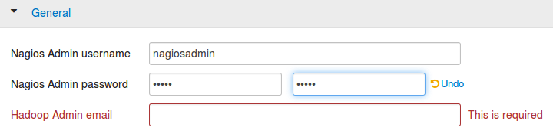

* 1. Click the Next button to continue.

1. Review the Configuration
   1. Notice the Review page allows you to review your complete install configuration. If you’re satisfied that everything is correct, click **Deploy** to start the installation process. (If you need to go back and make changes, you can use the Back button.)

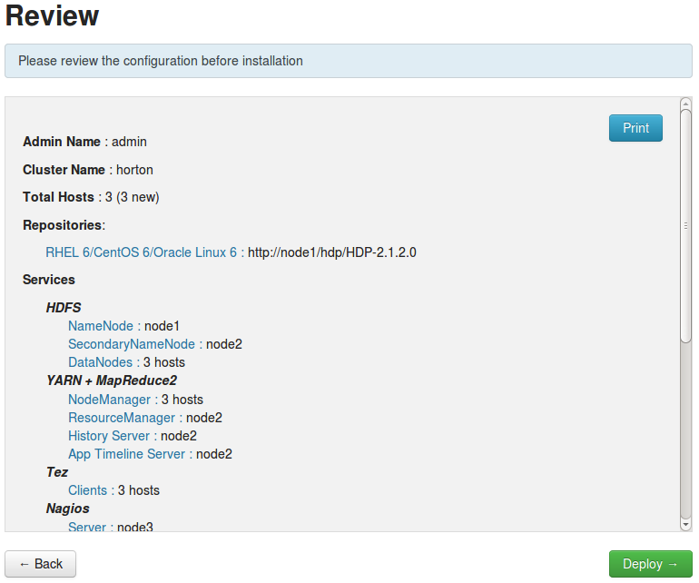

1. Wait for HDP to Install
   1. The installation will begin now. It will take up to 30 minutes to complete, depending on your computer processor and allocated RAM. You will see progress updates under the Status column as components are installed, tested, and started:

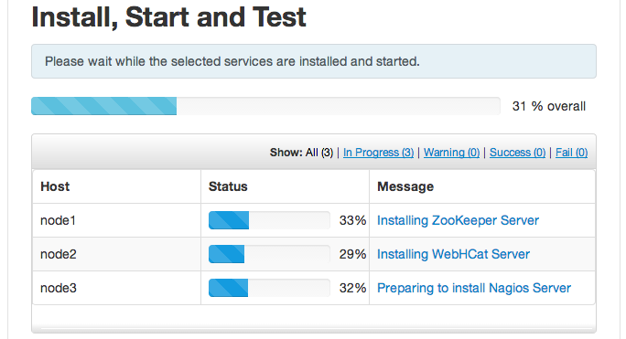

* 1. You should see the following screen if the installation completes successfully:

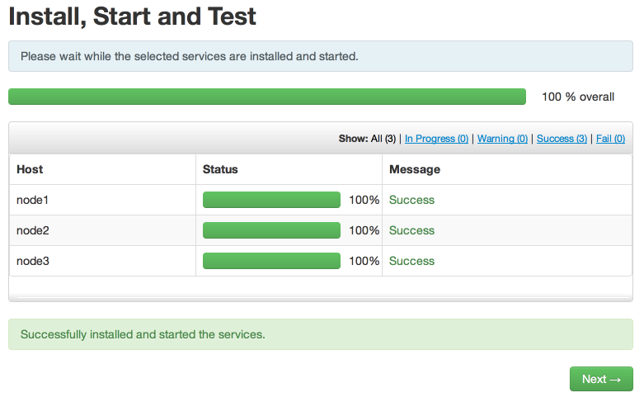

* 1. When the process completes, click Next to get a summary of the installation process. Check all configured services are on the expected nodes, then click Complete:

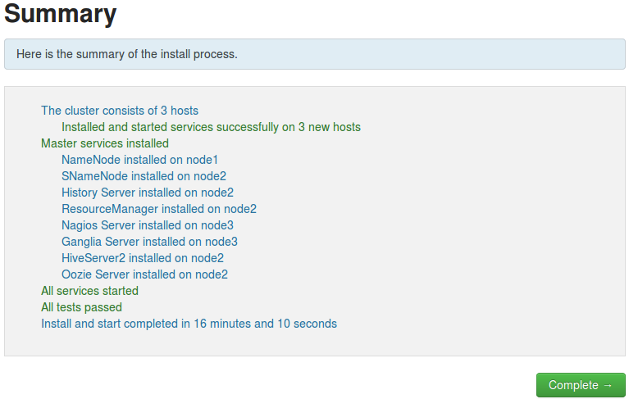

1. View the Ambari Dashboard
   1. After the install wizard completes, you will be directed to your cluster’s Ambari Dashboard page. Verify the DataNodes Live status shows 3/3:

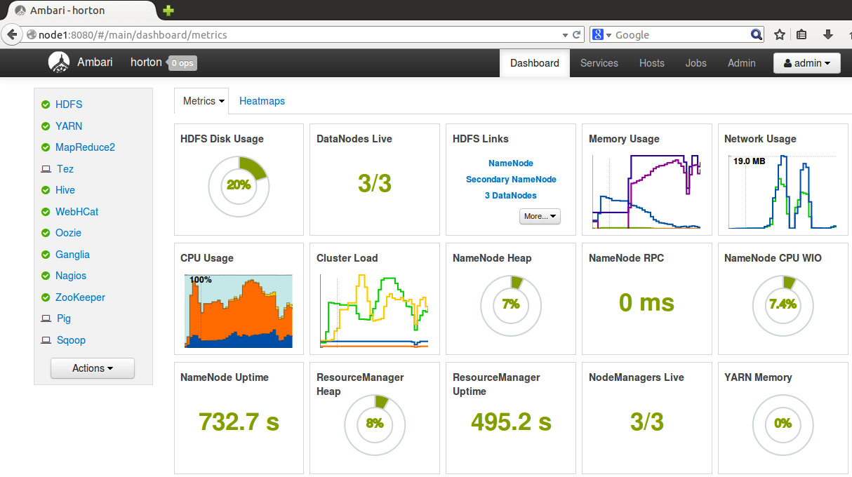

**RESULT**: You now have a running 3-node cluster of the Hortonworks Data Platform!